REHAN ASHRAF

BSE-B19-088

Web Development Content

# *Signup Page:*

Code:

Codeis available in zip file.

Result:

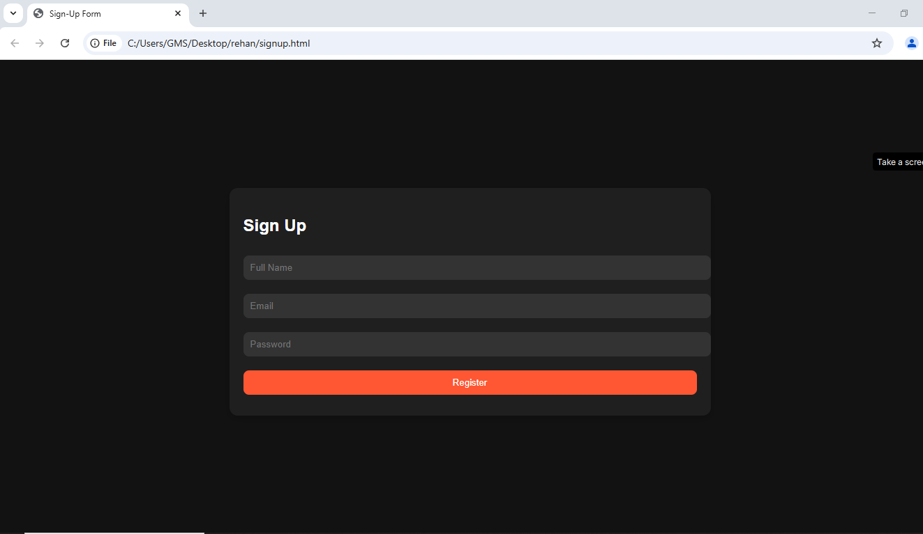

# *Home Page:*

code:

Code is available in zip file.

Result:

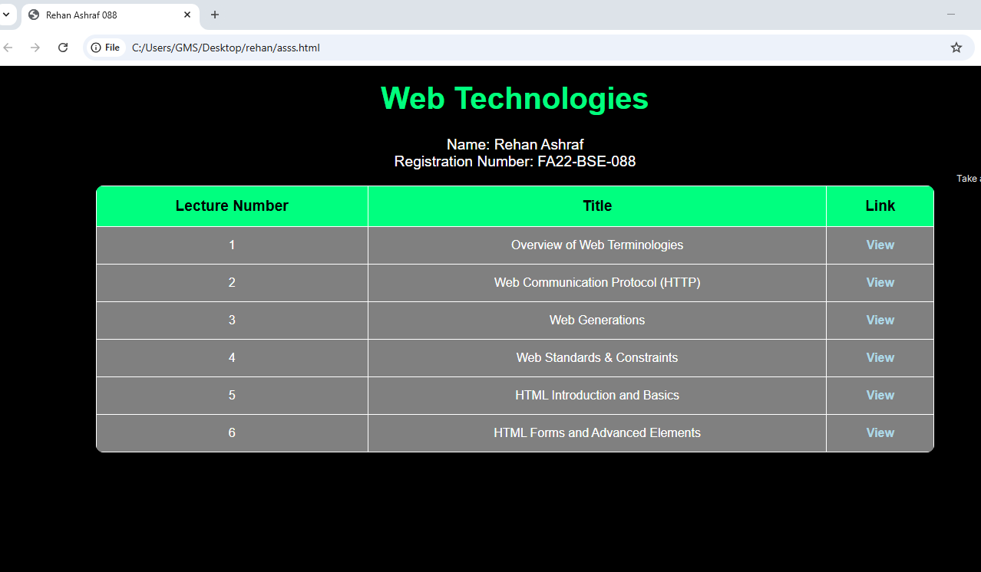

# *Lecture 1: Introduction to Web Terminologies, HTTP, Web Generations, and Standards & Constraints:*

Code:

Code is available in zip file.

Result:

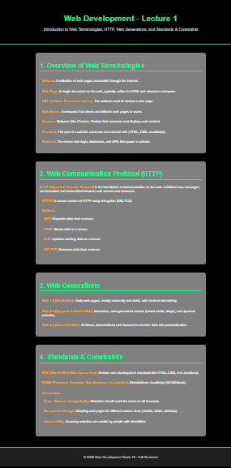

# *Lecture 2: Categories of Web Applications and Web Architectures:*

Code:

Code is available in zip file.

Result:

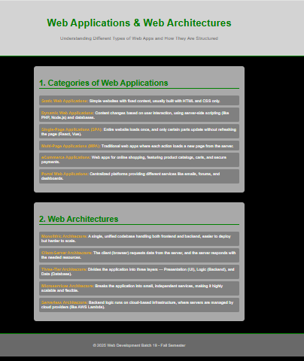

# *Lecture 3: Brief Overview of HTML, History of HTML, Difference between HTML & XHTML, Elements and Tags, Block Level vs. Inline Elements, and Introduction to HTML Validator:*

Code:

Code is available in zip file.

Result:

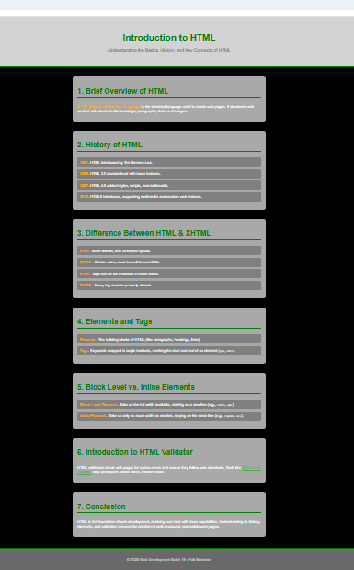

# *Lecture 4: Tables, Div, Span, and Layout Design in HTML:*

Code:

Code is available in zip file.

Result:

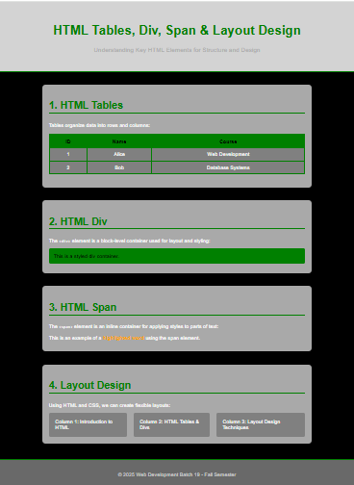

# *Lecture 5: Introduction to HTML5:*

Code:

Code is available in zip file.

Result:

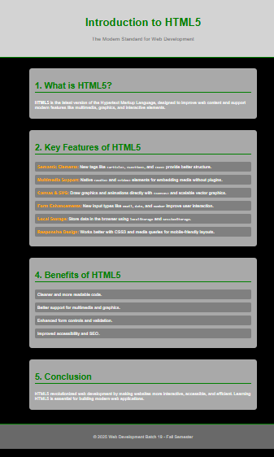

# *Lecture 6: HTML Forms:*

Code:

Code is available in zip file.

Result:

